**PRACITCAL-9**

**AIM:**

**Create an application to make INSERT,UPDATE,DELETE and SHOW operation on SQLite DATABASE.**

**PROGRAM CODES:**

* **Activity_main.xml:**

*<?*xml version="1.0" encoding="utf-8"*?>*<androidx.constraintlayout.widget.ConstraintLayout xmlns:android="http://schemas.android.com/apk/res/android"  
 xmlns:app="http://schemas.android.com/apk/res-auto"  
 xmlns:tools="http://schemas.android.com/tools"  
 android:layout_width="match_parent"  
 android:layout_height="match_parent"  
 tools:context=".MainActivity">  
  
 <TextView  
 android:id="@+id/display"  
 android:layout_width="wrap_content"  
 android:layout_height="wrap_content"  
 android:text="@string/parth_patel_19dcs098"  
 android:textSize="16sp"  
 app:layout_constraintBottom_toBottomOf="parent"  
 app:layout_constraintLeft_toLeftOf="parent"  
 app:layout_constraintRight_toRightOf="parent"  
 app:layout_constraintTop_toTopOf="parent"  
 app:layout_constraintVertical_bias="0.092" />  
  
 <EditText  
 android:id="@+id/etxtID"  
 android:layout_width="wrap_content"  
 android:layout_height="wrap_content"  
 android:layout_marginTop="152dp"  
 android:ems="10"  
 android:fontFamily="sans-serif-condensed"  
 android:hint="@string/id"  
 android:inputType="textPersonName"  
 android:minHeight="48dp"  
 app:layout_constraintEnd_toEndOf="parent"  
 app:layout_constraintStart_toStartOf="parent"  
 app:layout_constraintTop_toTopOf="parent"  
 android:importantForAutofill="no" />  
  
 <EditText  
 android:id="@+id/etxtName"  
 android:layout_width="wrap_content"  
 android:layout_height="wrap_content"  
 android:layout_marginTop="52dp"  
 android:ems="10"  
 android:fontFamily="sans-serif-condensed"  
 android:hint="@string/name2"  
 android:importantForAutofill="no"  
 android:inputType="textPersonName"  
 android:minHeight="48dp"  
 app:layout_constraintEnd_toEndOf="@+id/etxtID"  
 app:layout_constraintStart_toStartOf="@+id/etxtID"  
 app:layout_constraintTop_toBottomOf="@+id/etxtID"  
 tools:ignore="TextContrastCheck" />  
  
 <EditText  
 android:id="@+id/etxtMark"  
 android:layout_width="wrap_content"  
 android:layout_height="wrap_content"  
 android:layout_marginTop="72dp"  
 android:ems="10"  
 android:fontFamily="sans-serif-condensed"  
 android:hint="@string/marks"  
 android:inputType="number"  
 android:minHeight="48dp"  
 app:layout_constraintBottom_toBottomOf="parent"  
 app:layout_constraintEnd_toEndOf="@+id/etxtName"  
 app:layout_constraintHorizontal_bias="0.0"  
 app:layout_constraintStart_toStartOf="@+id/etxtName"  
 app:layout_constraintTop_toBottomOf="@+id/etxtName"  
 app:layout_constraintVertical_bias="0.016"  
 tools:ignore="SpeakableTextPresentCheck"  
 android:importantForAutofill="no" />  
  
 <Button  
 android:id="@+id/buttonInsert"  
 android:layout_width="wrap_content"  
 android:layout_height="wrap_content"  
 android:layout_marginTop="500dp"  
 android:backgroundTint="#8BC34A"  
 android:text="@string/insert"  
 android:textColor="#37474F"  
 app:layout_constraintEnd_toStartOf="@+id/buttonShow"  
 app:layout_constraintHorizontal_bias="0.0"  
 app:layout_constraintStart_toStartOf="@+id/etxtMark"  
 app:layout_constraintTop_toTopOf="parent" />  
  
 <Button  
 android:id="@+id/buttonShow"  
 android:layout_width="wrap_content"  
 android:layout_height="wrap_content"  
 android:layout_marginTop="500dp"  
 android:layout_marginEnd="12dp"  
 android:backgroundTint="#FFEB3B"  
 android:text="@string/show"  
 android:textColor="#BF360C"  
 app:layout_constraintEnd_toEndOf="@+id/etxtMark"  
 app:layout_constraintTop_toTopOf="parent" />  
  
 <Button  
 android:id="@+id/buttonUpdate"  
 android:layout_width="wrap_content"  
 android:layout_height="wrap_content"  
 android:layout_marginTop="44dp"  
 android:backgroundTint="#00BCD4"  
 android:text="@string/update"  
 android:textColor="@color/black"  
 app:layout_constraintBottom_toBottomOf="parent"  
 app:layout_constraintEnd_toStartOf="@+id/buttonDelete"  
 app:layout_constraintHorizontal_bias="0.0"  
 app:layout_constraintStart_toStartOf="@+id/buttonInsert"  
 app:layout_constraintTop_toBottomOf="@+id/buttonInsert"  
 app:layout_constraintVertical_bias="0.0"  
 tools:ignore="TextContrastCheck" />  
  
 <Button  
 android:id="@+id/buttonDelete"  
 android:layout_width="wrap_content"  
 android:layout_height="wrap_content"  
 android:backgroundTint="#F44336"  
 android:text="@string/delete"  
 android:textColor="#000000"  
 app:layout_constraintBottom_toBottomOf="parent"  
 app:layout_constraintEnd_toEndOf="@+id/buttonShow"  
 app:layout_constraintTop_toBottomOf="@+id/buttonShow"  
 app:layout_constraintVertical_bias="0.814"  
 tools:ignore="TextContrastCheck" />  
  
</androidx.constraintlayout.widget.ConstraintLayout>

* **Strings.xml:**

<resources>  
 <string name="app_name">DataBase</string>  
 <string name="parth_patel_19dcs098">PARTH PATEL-19DCS098</string>  
 <string name="insert">INSERT</string>  
 <string name="marks">Marks</string>  
 <string name="name">Name</string>  
 <string name="name2">NAME</string>  
 <string name="id">ID</string>  
 <string name="show">SHOW</string>  
 <string name="update">UPDATE</string>  
 <string name="delete">DELETE</string>  
</resources>

* **MainActivity.java:**

package com.parthnpatel.database;  
  
import androidx.appcompat.app.AlertDialog;  
import androidx.appcompat.app.AppCompatActivity;  
  
import android.database.Cursor;  
import android.os.Bundle;  
import android.view.View;  
import android.widget.Button;  
import android.widget.EditText;  
import android.widget.Toast;  
  
public class MainActivity extends AppCompatActivity {  
  
 EditText id,name,marks;  
 Button insert,update,delete,show;  
  
 helper mydb;  
  
  
 @Override  
 protected void onCreate(Bundle savedInstanceState) {  
 super.onCreate(savedInstanceState);  
 setContentView(R.layout.activity_main);  
  
 id=findViewById(R.id.etxtID);  
 name=findViewById(R.id.etxtName);  
 marks=findViewById(R.id.etxtMark);  
  
 insert=findViewById(R.id.buttonInsert);  
 show=findViewById(R.id.buttonShow);  
 update=findViewById(R.id.buttonUpdate);  
 delete=findViewById(R.id.buttonDelete);  
  
 mydb=new helper(MainActivity.this);  
  
 insert.setOnClickListener(new View.OnClickListener() {  
 @Override  
 public void onClick(View v) {  
 boolean flag=mydb.insert(name.getText().toString(),marks.getText().toString());  
 if (flag==true)  
 Toast.makeText(getApplicationContext(),"Data Inserted",Toast.LENGTH_SHORT).show();  
 else  
 Toast.makeText(getApplicationContext(),"Error in data insertion",Toast.LENGTH_SHORT).show();  
 }  
 });  
  
 show.setOnClickListener(new View.OnClickListener() {  
 @Override  
 public void onClick(View v) {  
 Cursor cursor=mydb.show();  
 StringBuffer stringBuffer =new StringBuffer();  
 if(cursor.getCount()<=0){  
 AlertDialog.Builder builder=new AlertDialog.Builder(MainActivity.this);  
 builder.setMessage("DATA NOT AVAILABLE!!");  
 builder.setTitle("STUDENT DATA");  
 builder.show();  
 }  
  
 else  
 {  
 while (cursor.moveToNext())  
 {  
 stringBuffer.append("ID:"+cursor.getString(0)+"\n");  
 stringBuffer.append("Name:"+cursor.getString(1)+"\n");  
 stringBuffer.append("Mark:"+cursor.getString(2)+"\n");  
 }  
  
  
 AlertDialog.Builder builder=new AlertDialog.Builder(MainActivity.this);  
 builder.setMessage(stringBuffer.toString());  
 builder.setTitle("STUDENT DATA");  
 builder.show();  
 }  
 }  
 });  
  
 update.setOnClickListener(new View.OnClickListener() {  
 @Override  
 public void onClick(View v) {  
 boolean flag=mydb.updateDB(id.getText().toString(),name.getText().toString(),marks.getText().toString());  
 if (flag==true)  
 {  
 Toast.makeText(getApplicationContext(),"DATA UPDATED SUCCESSFULLY",Toast.LENGTH_LONG).show();  
 }  
 else  
 Toast.makeText(getApplicationContext(),"ERROR: DATA CANNOT BE UPDATED",Toast.LENGTH_LONG).show();  
 }  
 });  
  
 delete.setOnClickListener(new View.OnClickListener() {  
 @Override  
 public void onClick(View v) {  
 Boolean flag=mydb.deleteRecord(id.getText().toString());  
 if(flag==true)  
 Toast.makeText(getApplicationContext(),"DATA DELETED",Toast.LENGTH_LONG).show();  
 else  
 Toast.makeText(getApplicationContext(),"ERROR: DATA CANNOT BE DELETED",Toast.LENGTH_LONG).show();  
  
 }  
 });  
  
 }  
}

* **helper.java:**

package com.parthnpatel.database;  
  
import android.content.ContentValues;  
import android.content.Context;  
import android.database.Cursor;  
import android.database.sqlite.SQLiteDatabase;  
import android.database.sqlite.SQLiteOpenHelper;  
  
public class helper extends SQLiteOpenHelper {  
  
 String dataBaseName="practical.db";  
 String tableName="computer";  
  
 String column_1="id";  
 String column_2="name";  
 String column_3="mark";  
  
 public helper(Context context){  
  
 super(context,"practical.db",null,1);  
 SQLiteDatabase db=this.getWritableDatabase();  
 }  
 @Override  
 public void onCreate(SQLiteDatabase db) {  
 db.execSQL("create table computer (id integer primary key autoincrement,name text,mark integer)");  
  
 }  
  
 @Override  
 public void onUpgrade(SQLiteDatabase db, int i, int i1) {  
 db.execSQL("drop table if exists "+tableName);  
  
 onCreate(db);  
 }  
  
 public boolean insert(String name,String mark)  
 {  
 SQLiteDatabase db=this.getWritableDatabase();  
 ContentValues contentValues=new ContentValues();  
 contentValues.put(column_2,name);  
 contentValues.put(column_3,mark);  
 long res=db.insert(tableName,null,contentValues);  
 if(res==-1)  
 {  
 return false;  
 }  
 else  
 {  
 return true;  
 }  
 }  
  
 public boolean updateDB(String id,String name, String marks)  
 {  
 SQLiteDatabase db=this.getWritableDatabase();  
 ContentValues contentValues=new ContentValues();  
 contentValues.put(column_1,id);  
 contentValues.put(column_2,name);  
 contentValues.put(column_3,marks);  
 int res=db.update(tableName,contentValues,"id=?",new String[] {id});  
 if(res>0)  
 return true;  
 else  
 return false;  
 }  
  
 public boolean deleteRecord(String id)  
 {  
 SQLiteDatabase db=this.getWritableDatabase();  
 int a=db.delete(tableName,"id=?",new String[] {id});  
 if(a>0)  
 return true;  
 else  
 return false;  
 }  
  
 public Cursor show()  
 {  
 SQLiteDatabase db=this.getWritableDatabase();  
 Cursor cursor=db.rawQuery("select * from "+tableName,null);  
 return cursor;  
 }  
  
  
}

**OUTPUT:**

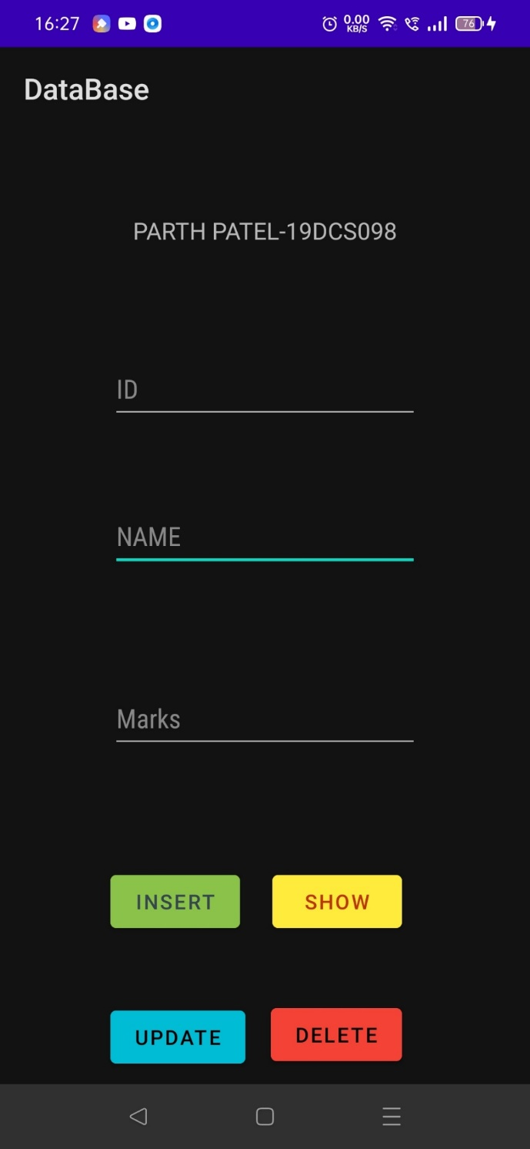

**BASIC UI**

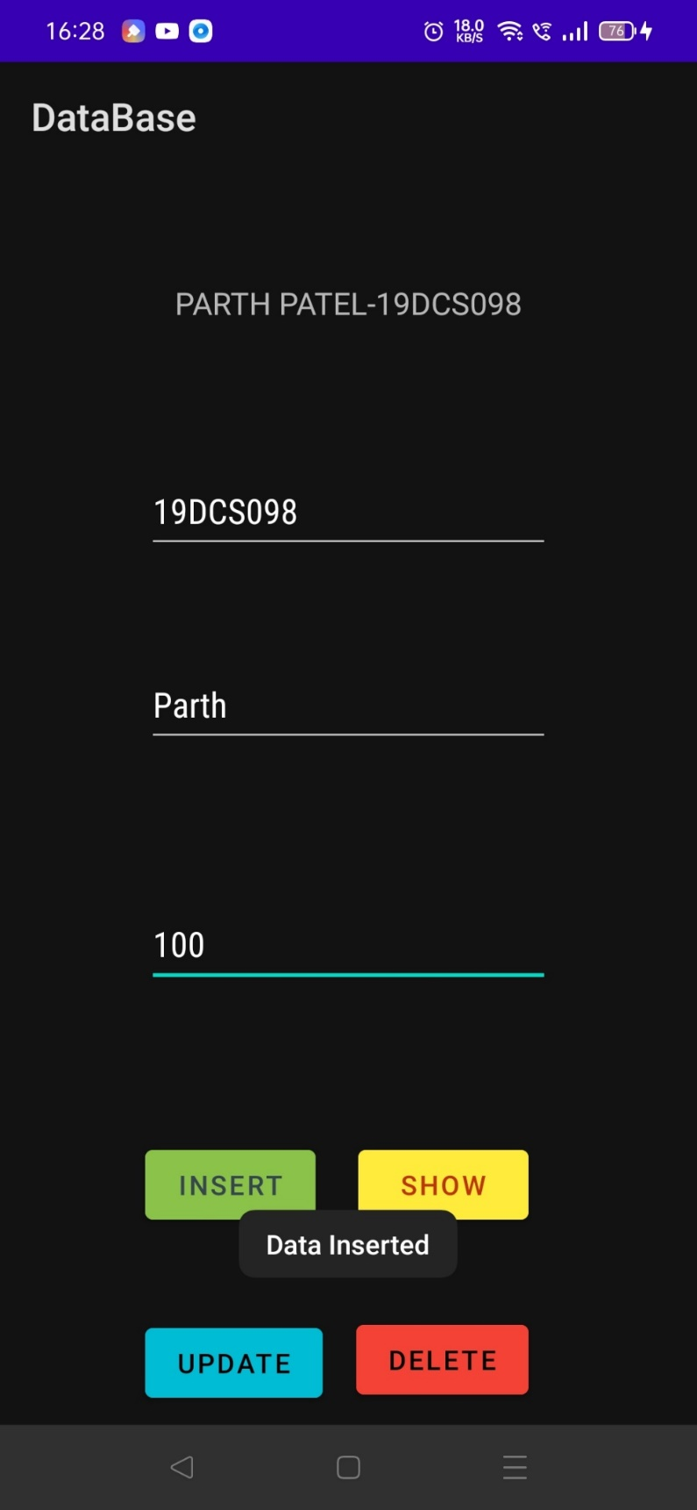

**DATA INSERTED**

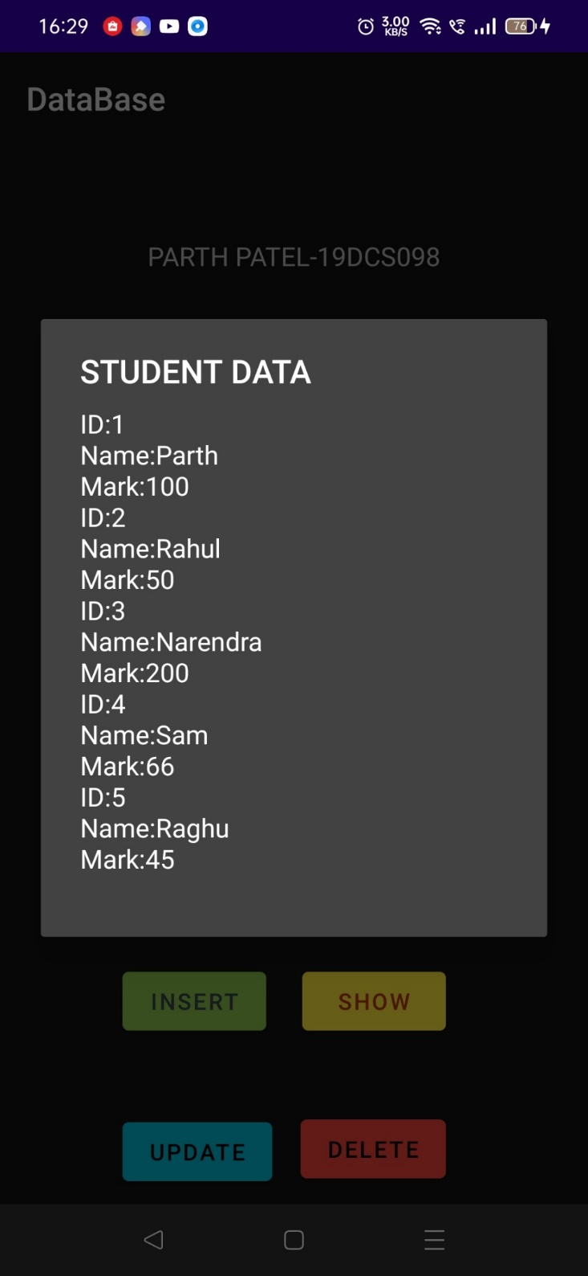

**DATA SHOWN**

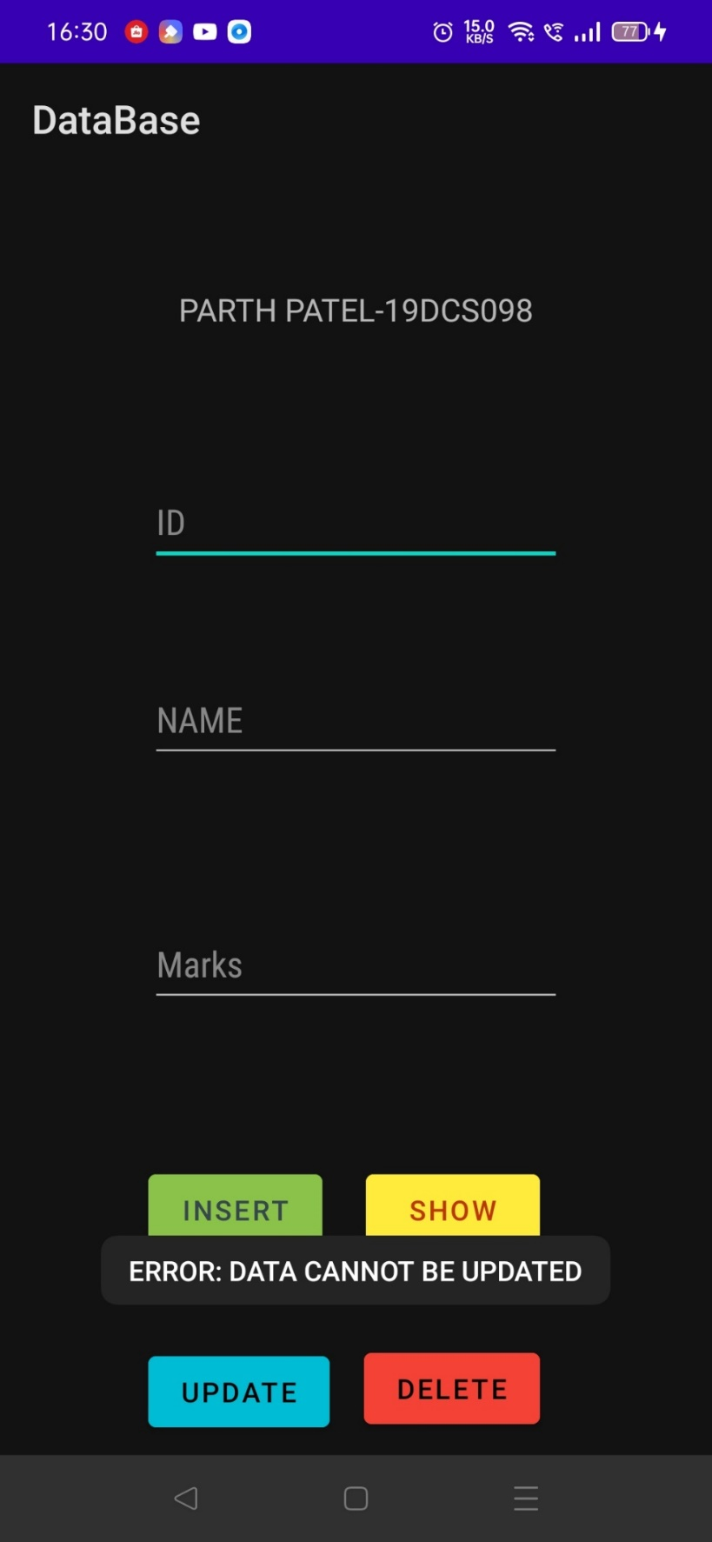

**EMPTY FIELDS NOT ALLOWED**

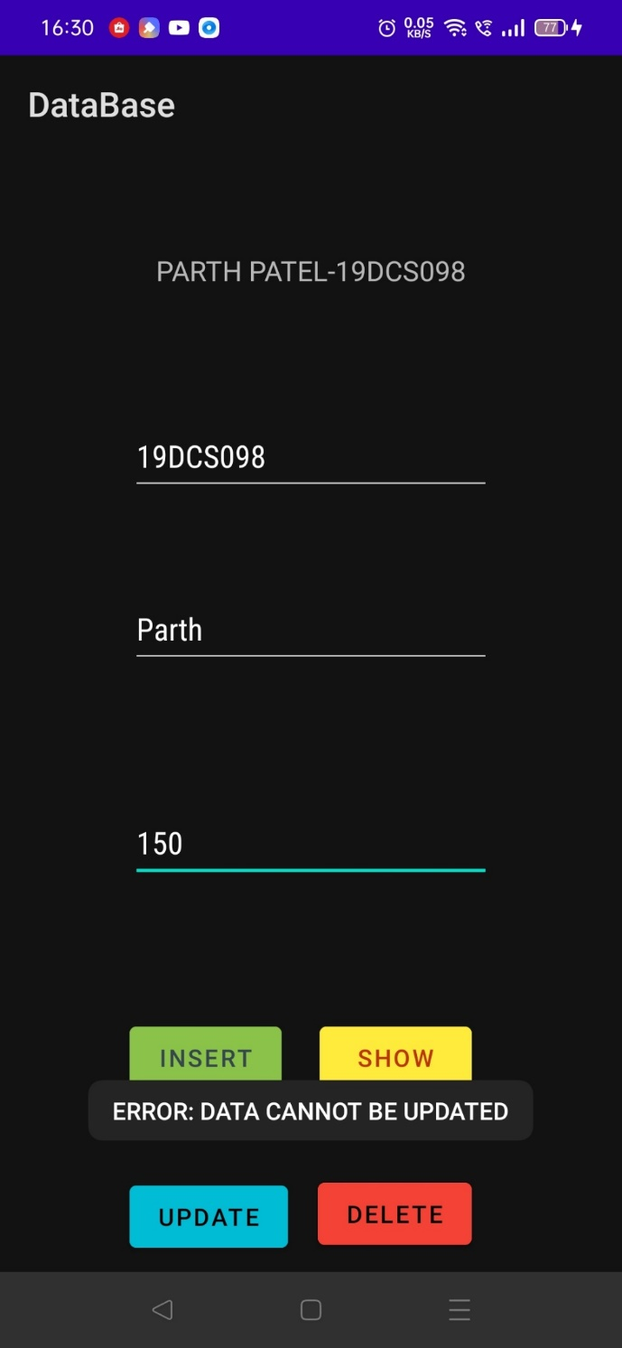

**DATA CAANOT BE UPDATED WITHOUT CORRECT INFORMATION**

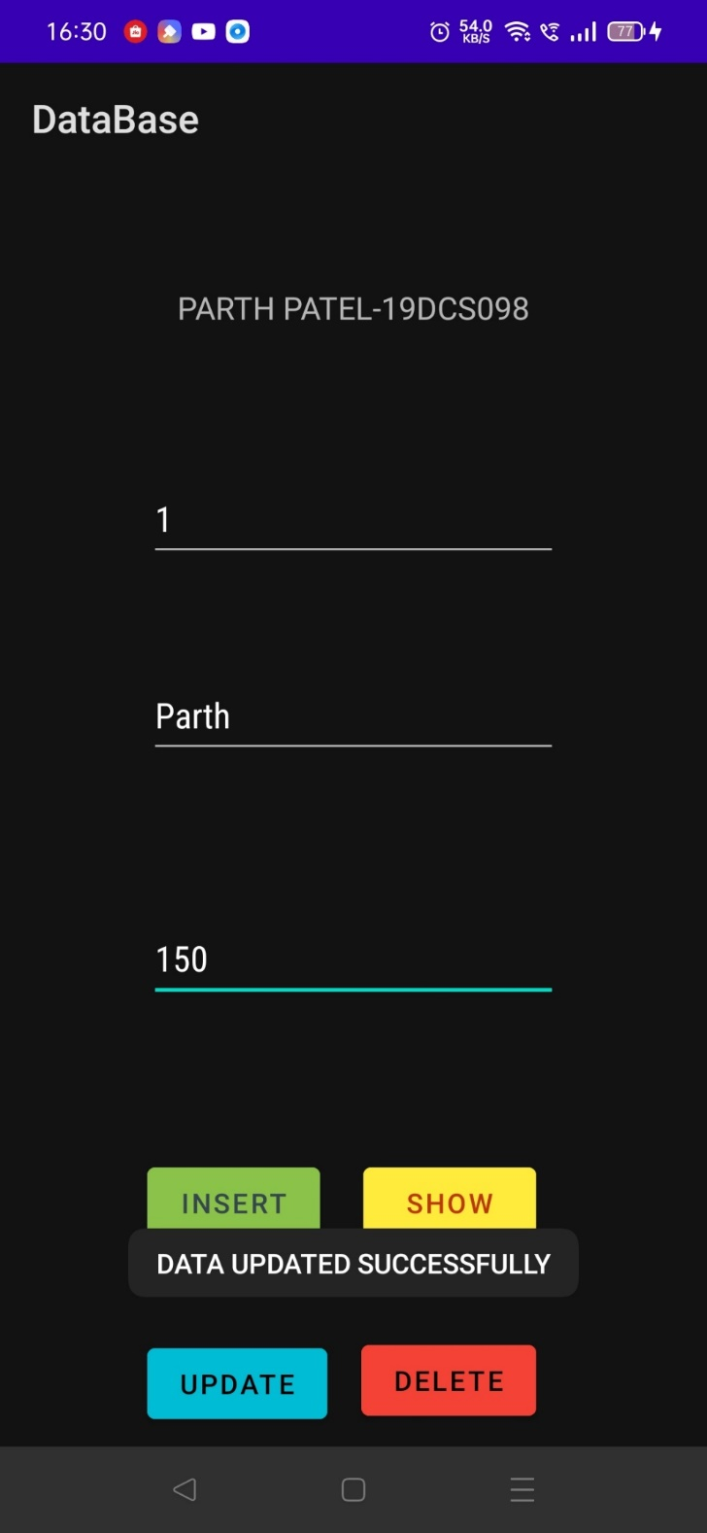

**DATA UPDATED**

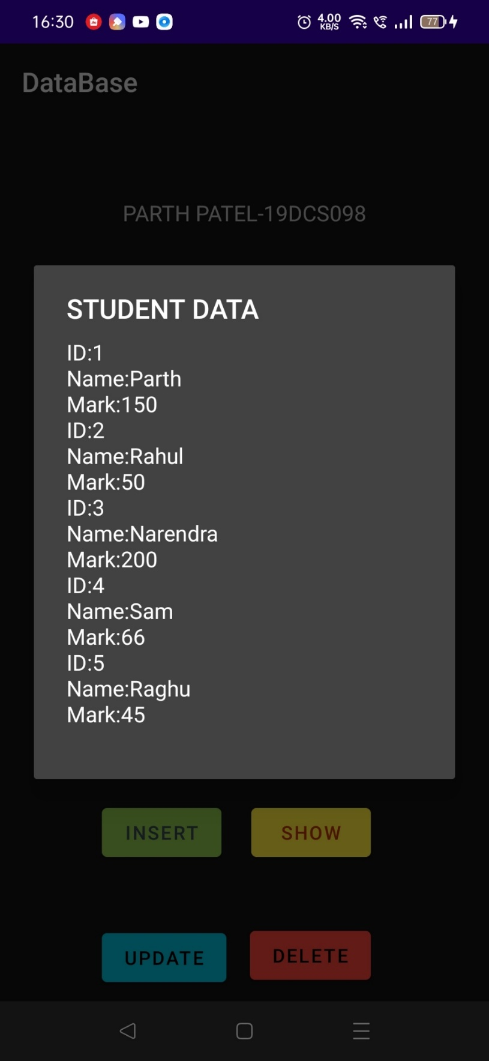

**UPDATED DATA REFLECTED**

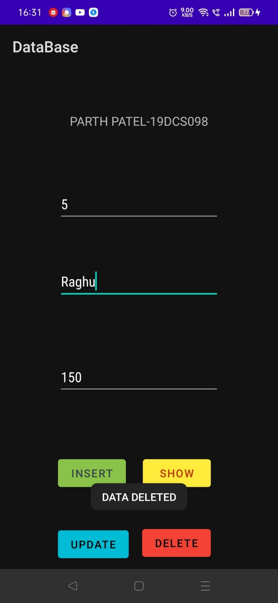

**DATA DELETED**

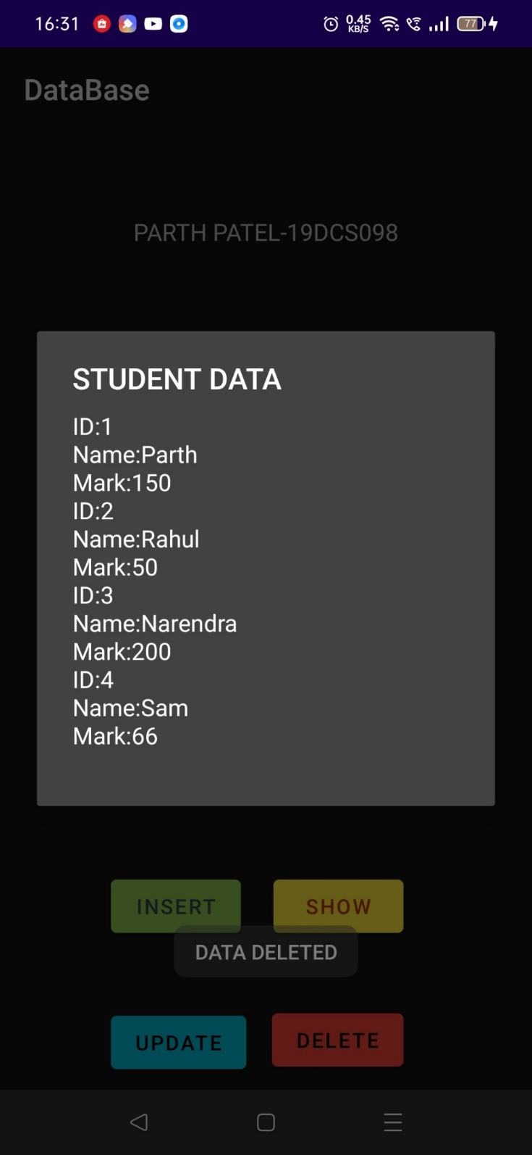

**DATA BASE UPDATED AFTER DELETION**